4.what is the difference between <ol>tag and <ul> tag? Write the basic stracture of both and explain where each is each.
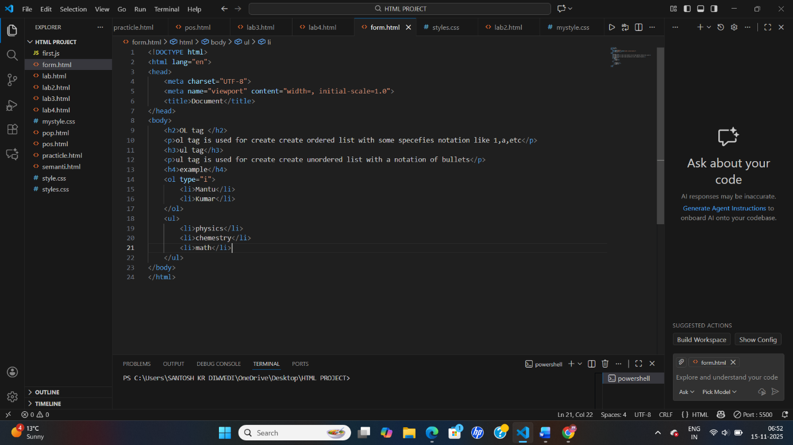
Output-
